

Special Educational & Disability Needs (SEND)

**Information for Parents**



**Special Educational Needs & Disability**

**Co-ordinator:**

Mrs L Hemming

**INTRODUCTION**

At St Mary’s Catholic Primary School and nursery, we pride ourselves on our special needs provision and we hope that you will find this booklet helpful. For the purpose of this booklet, we are referring to Special Educational Needs as SEND.

Cheshire East has introduced a new SEND Toolkit which is supporting the way schools organise their provision. The SEND Toolkit can be found under the education tab of the website: www.livewell.cheshireeast.gov.uk

There is a graduated approach to special educational needs to ensure that the process runs smoothly.

Information that you give us is stored securely and updated as and when any information changes e.g. phone numbers, addresses. All of the original information is stored onto our online special needs provision programme. This programme ensures that no information is missed and that our special needs coordinator (SENDCo) is always updated and can ensure that any amendments to provision are shared with the relevant members of staff.

In school every child has the right to QUALITY FIRST TEACHING (QFT) and the following diagram shows how we as a school follow the path of identifying and allocating provision for our children based on their needs.



**FIRST CONCERNS**

If you as the parent or a member of staff have a concern about your child’s education in school, this will be raised and suggestions on how to find a solution will be discussed with the class teacher. A variety of interventions and differentiation, additional to QFT will be put into place and if your child is still struggling, then a first concern discussion form (for EYFS children this is a record of discussion) will be completed by the class teacher and sent to the SENDCo. They will then be placed on the first concerns register by the SENDCo and a first concerns profile (for EYFS a My plan document) will be completed.

**MY PLAN**

**Name** –

Age –

Key worker –

Date -

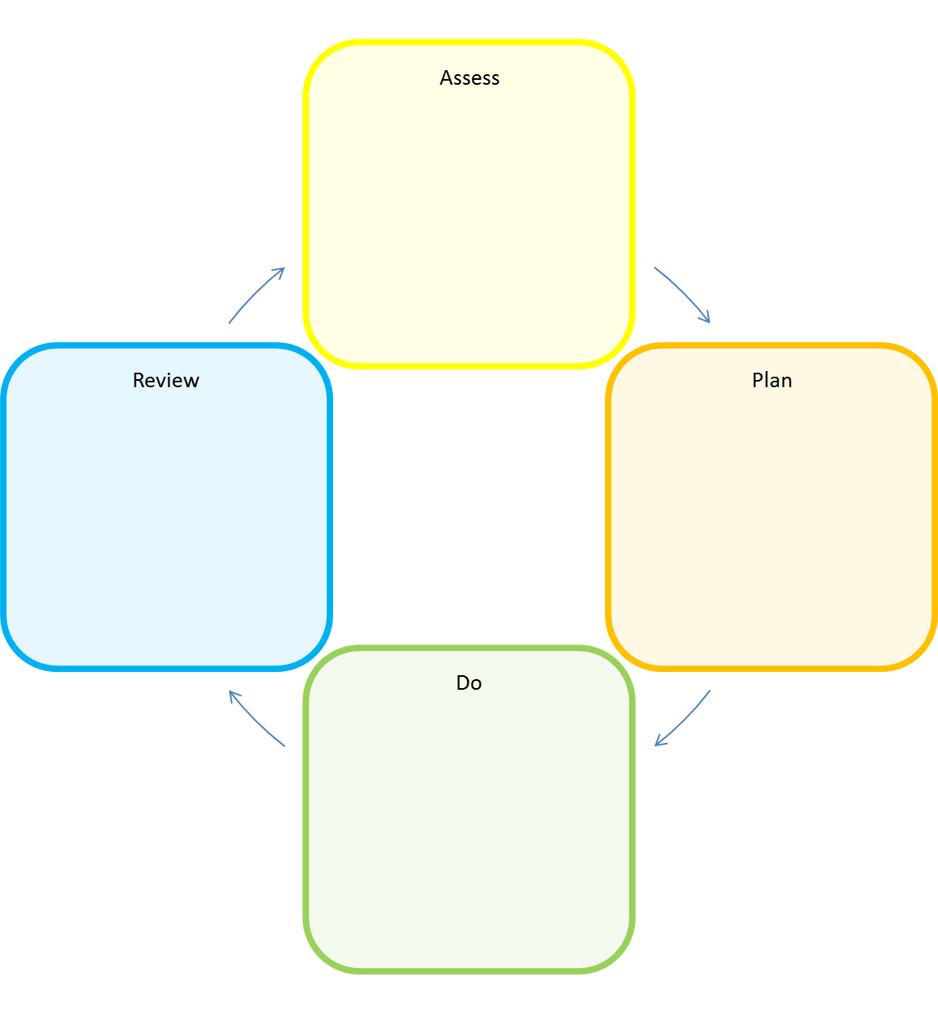

Child

All the relevant information will be shared with you every step of the way and paperwork will be signed. You will know the process of how we assess your child and how we are going to support your child’s needs.

A discussion form is also filled in and this will be added to our online database called CPOMS.

At the end of each academic year an ‘**Essential Information Sheet’** will be passed onto the next teacher with a summary of your child’s needs – these will be used during transition meetings and shared with all staff that will be working with your child.

**FIRST CONCERNS PROFILE**

|  |  |
| --- | --- |
| **Name:** | **Date of birth:** |
| **Year group:** | **Class:** |

|  |  |
| --- | --- |
| **Strengths** | **Needs** |
|  |  |
| **Desired Outcomes** | **Strategies** |
|  |  |
| **Review/Next Steps** | |
|  | |

|  |  |
| --- | --- |
| **Date created:** | **Last review date:** |
| **Staff signature:** | **Parent signature:** |
| **Young person signature:** |  |

As you can see when we have an initial concern, we keep records and if appropriate intervention is put into place to help your child with their learning. If we feel your child has ongoing concerns and is struggling to access their learning to make progress in line with children compared to the same age, then they will be moved to the SEND support.

**SEND SUPPORT**

Your child will be only be placed on the special needs register with parental consent.

 A SEND support plan (SSP) is then completed.

**SEND Support Plan for [child’s name]**

***Insert Picture of child***

**Child’s Details** – this form will only be filled in once, unless the details change

|  |  |  |  |  |  |
| --- | --- | --- | --- | --- | --- |
| Name |  | Date of Birth | | Year Group |  |
| Address |  | | | Post code |  |
| Ethnicity |  | Religion |  | Home language |  |

|  |
| --- |
| **My plan is supported by -** |

|  |  |  |  |
| --- | --- | --- | --- |
| Parent / Carer details (with parental responsibility) | | Cared for by the LA |  |
| Name |  | Relationship to the child |  |
| Address (if different from above) |  | Postcode |  |
| Telephone numbers |  | Email address |  |
| Name |  | Relationship to the child |  |
| Address |  | Post code |  |
| Telephone number |  | E-mail address |  |

|  |  |  |  |
| --- | --- | --- | --- |
| Educational setting details | | | |
| Name |  | Address |  |
| Contact person / position |  | Telephone number |  |
|  |  | Email Address |  |

|  |  |
| --- | --- |
| Details of child’s GP | |
| Name |  |
| Address |  |

**Professionals who will help and support**

**Contact details for involved professionals**

|  |  |  |  |
| --- | --- | --- | --- |
| **Name** | **Role** | **Contact Details**  **(Email address and/or Telephone Number)** | |
|  |  |  |  |
|  |  |  |  |
|  |  |  |  |
|  |  |  |  |
|  |  |  |  |
|  |  |  |  |

|  |  |  |  |
| --- | --- | --- | --- |
|  | **Yes/No** | **Date initiated** | **Date completed**  **(or state ‘ongoing’)** |
| Early Help Assessment e.g. Common Assessment Framework (CAF) |  |  |  |
| Child in Need |  |  |  |
| Child Protection |  |  |  |
| Care Plan/Personal Education Plan (Cared for Child) |  |  |  |
| Continuing Care/Continuing Health Care |  |  |  |
|  |  |  |  |
|  |  |  |  |
|  |  |  |  |
|  |  |  |  |

**Related plans or assessments** *(add to list as needed)*

This form is completed by the child:

| **All about me – by me** | | |
| --- | --- | --- |
| **What can I do well?** |  | **What do I need help with?** |
|  |  |  |

|  |  |  |
| --- | --- | --- |
| **What do I like and what makes me happy?** | **What’s important to me now?** | **How do I want to be supported?** |
|  |  |  |

There is another form for you, the parents to fill in.

A SEND Support Plan (SSP) is completed, which includes Smart Targets and is reviewed 3 times throughout an academic year.

Outside agencies may be called in to support your child and offer guidance too.

If the targets are not being met or your child is still struggling and there is ongoing concern, then the SENDCo along with you, the parents will move the child from SEND support to Complex needs. (Outside agencies will be involved at this stage).

**COMPLEX NEEDS**

If the SEND support plan (SSP) has not been successful, then your child is recognised as having complex special needs. At this stage, a needs assessment for an Educational Health Care plan (EHCP) can be completed. You as the parent will have sections to complete, your child will also complete a section, as the needs assessment process uses a child-centred approach. We as a school have an obligation to add evidence to support the plan, as do outside/external support services. The plans have to be as detailed as possible before they are sent off to the Cheshire East to be considered. Please be aware that if the application is accepted by the panel, the process can take more than 20 weeks from application to decision.

**TYPES OF NEED:** There are many different types of needs; for the purpose of SEND these are categorised into four sections:

**COMMUNICATION AND INTERACTION**

This includes:

**Speech, language and communication needs** (SLCN). Children and young people with SLCN have difficulty in communicating with others; this may be because they have difficulty saying what they want to and being understood by others, difficulty understanding what is being said to them or they do not understand or use social rules of communication

**Autistic Spectrum Condition** (ASC), including Asperger’s Syndrome

**COGNITION AND LEARNING**

Support for learning difficulties may be required when children and young people learn at a slower pace than their peers. Learning difficulties cover a wide range of needs, including:

**Moderate learning difficulties** (MLD)

**Severe learning difficulties** (SLD) where children and young people are likely to need support in all areas of the curriculum and associated difficulties with mobility and communication

**Profound and multiple learning difficulties** (PMLD) where children and young people are likely to have severe and complex learning difficulties as well as a physical disability or sensory impairment

**Specific learning difficulties** (SpLD) affect one or more specific aspects of learning. This includes a range of conditions such as dyslexia, dyscalculia and dyspraxia.

**SOCIAL, EMOTIONAL AND MENTAL HEALTH (SEMH)**

Children and young people may experience a wide range of social and emotional difficulties which manifest themselves in many ways. These may include becoming **withdrawn or isolated**, as well as **displaying challenging, disruptive or disturbing behaviour**. These behaviours may reflect underlying mental health difficulties such as anxiety or depression, self-harming, substance misuse, eating disorders or physical symptoms that are medically unexplained. Other children and young people may have disorders such as **attention deficit disorder (ADD)**, **attention deficit hyperactive disorder (ADHD)** or **attachment disorder**.

**SENSORY AND/OR PHYSICAL NEEDS**

Some children and young people require special educational provision because they have a disability which prevents or hinders them from making use of the educational facilities generally provided. This includes children and young people with:

* **Visual impairment** (VI)
* **Hearing impairment** (HI)
* **Multi-sensory impairment** (MSI) (a combination of vision and hearing difficulties)
* **Physical disability** (PD)

**PUPIL PREMIUM**

Pupil Premium is additional funding that your child’s school can claim. It is available for any child who qualifies for free school meals due to their family income.

The money can be used by the school to help to provide more support for your child, to help develop children’s academic progress, their self-esteem or their social and emotional skills.

Where a child is eligible for Pupil premium funding, a personalised pupil premium map will be put into place which clearly sets out provisions and support. This information is kept on the school’s record system. Please visit the school’s website for information on St. Mary’s Pupil Premium strategy.

For more information on eligibility for Pupil Premium please contact Cheshire East.



We hope that you find this document useful to support your child through school.

If you have any questions, please contact school on 01270 685174

Or email [admin@stmarysrc.cheshire.sch.uk](mailto:admin@stmarysrc.cheshire.sch.uk)